**Minutes of the Annual General Meeting of the District of Kenora Unincorporated Areas Ratepayers Association held on Thursday, September 21, 2023 at the KDSB Boardroom & via teleconference (Zoom)**

The meeting commenced at 7:05 PM, called to order by Barry Baltessen, who chaired the meeting.

Attending at KDSB Boardroom: Barry Baltessen, Ed Murray

Attending via ZOOM: Bob Stewart, Dennis Wallace, Mark Sobchuk, Laurie Huffman, Bob Cymbalisty

**1) Agenda**

Motion to approve the agenda, moved by Dennis Wallace, seconded by Laurie Huffman. Called, carried. The chair called for declaration of pecuniary interest related to the agenda items, none declared.

**2) Minutes**

The minutes of the 2022 annual meeting and Board of Directors meetings held November 17, 2022 and February 23, March 23, May 18, July 11, 2023 were approved as submitted, separate files attached. Moved by Ed Murray, seconded by Bob Stewart. Called, carried.

**3) Director’s Actions**

Motion to approve the director’s actions since the 2022 AGM. Moved by Dennis Wallace, seconded by Mark Sobchuk. Called, carried

**4) Financial Report**

Barry Baltessen presented the annual financial report (April 1, 2022-March 31, 2023) and an update on the financial situation as at August 31, 2023.

Statements approved by members on a motion moved by Barry Baltessen, seconded by Ed Murray.

(Copies of statements attached as separate files). Called, carried.

**5) Bylaws**

Bob Stewart reviewed the revised bylaws for the District of Kenora Unincorporated Areas Ratepayers Association as circulated on July 14, 2023 in order to meet the requirements of the Ontario Not-for-profit Corporations Act of 2021; and to reflect the current operation and activities of the association.

Motion to approve the revised bylaws moved by Bob Stewart and seconded by Laurie Huffman. (Copy of amended bylaws attached as separate file). Called, carried.

**6) Waive Requirement for Audit or Review**

Motion to approve the waiving of an audit or review for the 2023-2024 fiscal year as permitted under the Ontario Not-for-profit Corporations Act 2021 for Public Benefit Corporations moved by Bob Stewart, seconded by Dennis Wallace. Called, carried.

**7) Director’s Reports**

*Provincial Land Tax*

*Energy Issues*

*High Speed Broadband*

*All Nations Health Partners*

*KDSB Activities*

*Federal Election Boundary Changes*

Moved by Ed Murray, seconded by Mark Sobchuk that all reports be accepted as submitted, copies attached. Called, carried.

**8) Nominating Report & Election of Directors**

Moved by Bob Stewart and seconded by Dennis Wallace that their report be accepted as amended to reflect the resignation of Ken Bracken, copy attached. The following are the DoKURA board of directors and officers for the Sept 2023 – September, 2024 term. Called, carried.

*Officers*

President – Vacant

Vice-President – Ed Murray (to 2025)

Treasurer – Barry Baltessen (to 2024)

Secretary – Barry Baltessen (2024)

*Directors at large*

Bob Stewart – (to 2024)

Ed Murray (to 2025)

*Kenora District Service Board TWOMO representatives*

Laurie Huffman – Oxdrift (to Dec 2026)

Barry Baltessen – Lake of the Woods North (to Dec 2026)

Mark Sobchuk – Lac Seul (to Dec 2026)

Dennis Wallace – Lake of the Woods South (to Dec 2026)

**9) Signing Authority**

Moved by Ed Murray, seconded by Laurie Huffman that the designation of signing officers for banking and financial institute purposes be accepted as follows:  
Primary signatory – Barry Baltessen as treasurer.

Endorsement by Bob Stewart as Director or Dennis Wallace as Director.

Called, carried.

**10) 2023 AGM**

Discussion related to the 2024 AGM raised the following points:

* Must be scheduled for no later than 90 days following our March 31 year-end
* Agreed to hold the meeting at a location other than the KDSB boardroom.
* Need to allow time to close books and prepare year-end financial statements
* Should pursue our own ZOOM account so we can control scheduling and access
* Secretary will poll board members to determine a date and location, recognizing that an earlier date than June 30 is preferred
* Quality internet service is essential to allow for remote access to the meeting.

Moved by Laurie Huffman that the meeting be adjourned at 7:45 pm.

**Report to the 2023 AGM**

**District of Kenora Unincorporated Areas Ratepayers Association**

**Provincial Land Tax**

The Provincial Land Tax continues to be an area of concern for the association. In January 2023, DoKURA made a formal presentation to the provincial budget committee during its meeting in Kenora. Two key issues were raised. The first is the ongoing delay in updating assessments and its impact on taxation disparities. A province-wide re-assessment, scheduled to take effect for the 2020 tax year was deferred by province as a cost control measure due to CoVID; that deferral has been extended twice and now the province announced in August a further delay as it is undertaking a review of the MPAC process due to concerns about the accuracy of assessments.

Our presentation also made note of the need to adjust both the PLT rate and the Education Tax Rate (both set annually by provincial regulation) to reflect any general inflationary increase in property assessment values in unincorporated areas.

The second key issue was the continuing need for an annual report to those paying the PLT on how much the tax collected and where the funds were assigned by service. There are over 60,000 PLT properties, of which 45,000 are occupied residential properties. In total the province currently collects about $40 million annually through the tax which forms part of the province’s General Revenues. While the province lists what services the tax helps pay for, it does not provide an annual breakdown of how much each service costs in total and how much of the PLT collected goes to help cover those costs. The last time this was done was during the 2013-2016 PLT reform consultations, at which time it was calculated co-funded service costs were approximately $65 million annually.

Major services co-funded include:

Policing

Local Roads

Land Ambulance

Social Housing

Social Support programs

Child care

Local fire protection

Public Health

DoKURA continues to raise the issue of the need for an annual report to taxpayers in meetings with ministry representatives and in letters to elected officials.

Submitted by director Bob Stewart

Sept 2023

**Report to the 2023 AGM**

**District of Kenora Unincorporated Areas Ratepayers Association**

**Energy Issues**

During the past year, DoKURA has been active on issues related to the delivery, reliability and pricing of energy in our region.

We provided detailed information on the November 1, 2022 rate increase, the net result of a decrease in the per kilowatt hour rates and a reduction in the Ontario Electricity Rebate (OER).

We also reported on the elimination of the Seasonal Rate Class, with cost increases phased in over a ten-year period. Low use customers will be impacted the most, with increases dropping as consumption rises. The impact of the change, with increases to be phased in over a 10-year period, will vary depending on electricity usage this year as the utility continues its move towards fully fixed monthly service charges. In this area, rural customers are being moved to the R2 class. Customers using no electricity, or a minimal amount will see about a $7 monthly increase in charges ($22 on a quarterly bill). The increase will drop as consumption rises and the reduction in the per kwh component of the service charge drops. That part of the Hydro One monthly charge will be 1.91 cents per kwh compared to 3.19 cents in 2022. At about 750 kwh of monthly consumption the service charge increase disappears and customers will experience a savings.

We also reported on poor quality and reliability of Hydro One service in the Clearwater Bay area. Our representatives discussed this issue at length with several Hydro One officials on numerous occasions. We continue to seek a satisfactory resolution to this issue.

Information was provided to ensure residents were aware of two programs designed to help reduce energy costs, the Ultras-Low Electricity Rate and Peak Perks.

We will continue to monitor energy issues in order to keep unincorporated area residents informed.

Submitted by director Barry Baltessen

Sept 2023

**Report to the 2023 AGM**

**District of Kenora Unincorporated Areas Ratepayers Association**

**High-Speed Broadband**

The cost and lack of access to high-speed Internet service continues to be an area of concern for the association.

A report in May of 2023 by Blue Sky Net, a not-for-profit economic group, noted that in the Kenora District only 16 per cent of households in unincorporated areas have access to high-speed broadband Internet. In the Thunder Bay and Rainy River districts the percentage is in the 10 per cent range. Providing universal access to high-speed broadband, defined as a wired service capable of download/upload speeds of 50MB/10MB, is now a commitment of both the federal and Ontario governments.

Based on our review of current availability and existing service expansion plans, many areas of the district will still be without this essential service after the provincial deadline date of December 2025 to have such service available province-wide. This leaves residents of unincorporated areas with costly off-air or satellite service as their only options, if it is available in their area. These services cost upwards of $160 monthly, while a similar, or greater level of service is available in urban areas for less than $50 monthly.

DoKURA has raised this concern in letters and submissions to several provincial ministries and elected officials. An in-person meeting was held with federal MP Eric Melillo in August specifically to discuss the issue of high cost and the current federal subsidy program; a similar meeting has been requested with Kinga Surma, Minister of Infrastructure, to discuss the provincial plans for service expansion and the need for a provincial subsidy program. Our concerns were also raised in an online Telecommunications Consultation hearing session conducted by the Ontario NDP dealing with high cell phone costs and lack of reliable Internet service in Northern and rural communities across Ontario.

We will continue to press the issue with various levels of government and service providers in the region.

Submitted by director Bob Stewart

Sept 2023

**Report to the 2023 AGM**

**District of Kenora Unincorporated Areas Ratepayers Association**

**All Nations Health Partners**

In May of 2018 DoKURA, in its capacity of representing unincorporated area residents of the Kenora District – in particular those in the immediate Kenora area – was asked if it would like to participate in the All Nations Health Partners initiative (ANHP).

The ANHP is the successor to the Kenora Area Health Care Working Group created in 2015 to address shortages of physicians and other health professionals and access to health care in the Kenora region. DoKURA director Bob Stewart is DoKURA’s representative on the group. The partnership’s terms of reference state: **The primary purpose of the partnership is to facilitate development and encourage (incremental) implementation of a collective vision for health care in the Kenora area.**

Members involved in the partnership include: The Kenora Chiefs Advisory – representing 8 of the 10 First Nations in the Kenora area; Grand Council Treaty 3; the municipalities of Kenora and Sioux Narrows Nestor Falls and DoKURA; the Kenora Metis Council; primary health care representatives; Waasegiizhig Nanaandawe’iyewigamig (Indigenous Health Care); Sunset Family Health Team (the Paterson Clinic, Keewatin and Lakeside clinics); the Northwestern Health Unit; Pinecrest Home for the Aged; Kenora District Services Board; Firefly (children’s services), a physicians and health care worker group and a patient and Elders committee.

During the past year the group has continued its efforts towards developing an Ontario Health Team which will operate under the umbrella of the ANHP. Waasegiizhig Nanaandawe’iyewigamig (the local Indigenous Health Care) clinic made public its plans for a new building in January. The group (known as WHNAC) currently rents space in the former Kenora Federal Building, having previously been in the former Kantola Motors Building and an adjacent residential property. The new multi-level building is to be built at the corner of Chipman and First Street South on property the organization acquired several years ago. No firm construction date has been approved yet. It will house the clinic, doctor and various other medical program offices and serve as a local base for the group’s doctors, nurses and other medical staff who visit area First Nations communities.

In July, the ANHP announced it would be moving forward with consultations to investigate the development of a safe drug consumption and treatment facility in Kenora. The ANHP news release noted this work is a follow up on a Northwestern health Unit study on the need for a safe consumption site and does not commit the organization to creating such a facility, only to further study the need for one and how it could be developed.

Submitted by director Bob Stewart

Sept 2023

**Report to the 2023 AGM  
District of Kenora Unincorporated Areas Ratepayers Association  
KDSB Activities & Strategic Planning Report**

KDSB Activities

On October 24, 2022 municipal, school board and district services board elections were conducted across Ontario. There are 4 seats allocated to Unincorporated Wards for representation on the Kenora District Services Board. As a result of this election, your representatives on the Kenora District Services Board are:

Lac Seul – Mark Sobchuck (Returning)  
Lake of the Woods South – Dennis Wallace  
Lake of the Woods North – Barry Baltessen (Returning - Acclaimed)  
Oxdrift – Laurie Huffman

This year’s election was conducted using a vote-by-mail process for the first time. As a result, there was a significant increase in voter turnout and increased awareness for the services delivered by the KDSB. DoKURA continues to provide contract services to the KDSB, looking to improve communications and identify services required by unincorporated residents.

At its January Board meeting, the KDSB elected Barry Baltessen to serve another year as chair and Mark Sobchuck was elected as Vice-Chair and is also the Chair of the Finance & Audit Committee.

The Association continues to work with the KDSB on the Vermilion Bay ambulance base. An additional crew working out of the Dryden base continues to help with immediate pressure on the ambulance service. The KDSB continues to support the township of Machin on the development of an ambulance base in Vermilion Bay.

We are also continuing consultation with the KDSB on the delivery of paramedicine services to unincorporated residents. While the roll-out has been slower than anticipated, we continue to see improvements in services to residents across the region by bringing wellness checks right to people’s homes.

DoKURA Strategic Planning

In May of 2022, we engaged a local consulting firm (Reach Marketing) to help us review and redefine our organization and develop an action plan to increase the profile of DoKURA, building on existing community outreach, strategic partnerships and funding.

We continue to work with Reach Marketing to refine our approach to community engagement. As part of that process, we have adopted a policy that reflects the principles of Canada’s Anti-Spam Legislation (CASL) & the Personal Information Protection & Electronic Documents Act (PIPED.

Areas of focus for the future include:

- Improvements to the website to better define issues we are working on, such as electricity costs, taxation and broadband access.

- Improve our working relationship with KDSB to better serve residents in the unincorporated area.

- Expand and improve our communications with all stakeholders.

- Explore funding sources to enable hiring of an employee or consultants to assist volunteer directors.

- Expand and improve working relationships with various existing and potential partners.

- Tighten and expand our governance structure to increase capacity, efficiency and effectiveness.

Submitted by director Barry Baltessen  
September 2023

**Report to the 2023 AGM  
District of Kenora Unincorporated Areas Ratepayers Association  
Federal Election Boundary Changes**

The Federal Electoral Boundaries Commission for the Province of Ontario published its final report in February, which includes redrawn electoral maps for many parts of the province, including the north. Every 10 years the commission revisits the electoral map based on the latest census population data. The goal is for each district to have 116,590 voting age people in it. Although even with the new changes, all northern Ontario's ridings fall short of the quota.

The proposed redistribution was looking to reduce the number of ridings in the western portion of Northern Ontario by combining most of the population of the existing Kenora District and Thunder Bay—Rainy River District into Kenora—Thunder Bay—Rainy River and would create the new Electoral District of Kiiwetinoong—Mushkegowuk, a large and sparsely populated far north riding spanning from the Manitoba to Quebec border.

Extensive lobbying from DoKURA as well as federal, provincial, and municipal elected officials in the District of Kenora did result in amendments that generally preserved the three existing ridings in the western portion of Northern Ontario.  
- Kenora-Kiiwetinoong  
- Thunder Bay-Rainy River  
- Thunder Bay-Superior North

The eastern portion of Northern Ontario could have one less riding in the next federal election if the report receives House of Commons approval. Northern Ontario currently has 10 federal ridings, but if the latest electoral map is approved, that will drop to nine the next time voters go to the polls.

The proposed electoral map for Northern Ontario is attached on page 2 of this report.

Submitted by director Barry Baltessen  
September 2023

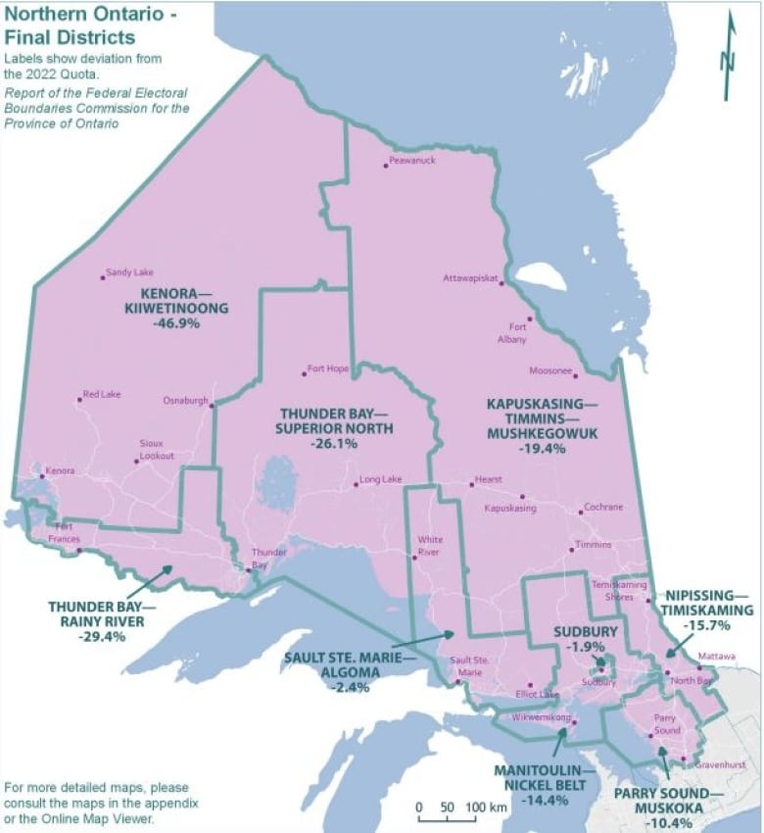

**Report to the 2023 AGM**

**District of Kenora Unincorporated Areas Ratepayers Association**

**Nominating committee Report**

Current directors have been contacted and their intentions confirmed verbally or by email.

**Board members**

Barry Baltessen – KDSB representative for Lake of the Woods North to 2026/willing to serve as Secretary/Treasurer

Mark Sobchuk – KDSB rep for Lac Seul to 2026

Dennis Wallace – KDSB rep for Lake of the Woods South to 2026

Laurie Hoffman – KDSB rep for Oxdrift to 2026

Jack McKenzie – stepping down

Ed Murray – willing to serve as a director & Vice-President (current term ends in 2023)

Bob Stewart - willing to serve as director (current term ends in 2024)

Ken Bracken – stepping down

The nominating committee puts forward the following nominees as directors at large for the 2024-2025 term:

Ed Murray

**Officers**

President (Vacant)

Barry Baltessen – Secretary/Treasurer (term ends 2024)

Ed Murray - Vice-President (term ends 2023)

The committee puts forward the following nominees as executive officers for the 2024-2025 term:

Ed Murray - Vice-president

As no one has indicated a willingness to serve as President, the nominating committee recommends the association continue its practice of the past two years of having the directors assume that responsibility acting as a committee of the whole, with specific duties assigned to individual directors as needed.

Submitted by Dennis Wallace and Bob Stewart

Sept 2023